 [Translated from German to English - www.onlinedoctranslator.com](https://www.onlinedoctranslator.com/en/?utm_source=onlinedoctranslator&utm_medium=docx&utm_campaign=attribution)

**1 Mechanics**

Turning station technical documentation

© by Dr.-Ing. Paul Christiani GmbH & Co. KG 5

**1.1 Functional description**

The turning station functional assembly is used to rotate workpieces by 90°

For this purpose, the workpiece is placed in a holder and rotated using a pneumatic rotary cylinder.­

When a workpiece is inserted into the holder, it is positioned by the insertion bevels.­

The turning station is mounted on a base plate and can be mounted individually or together with other functional assemblies on an aluminum profile plate.­

Two 8-bit transfer connectors are available as transfer modules for connection to two digital PLC inputs and two digital PLC outputs.

The supply voltage for the functional module is 24 VDC and is established via the 10-pin connecting cable. The air supply is via a 4 mm air connection, and the operating pressure is 4 bar.

The intended workpieces have a size of 50 x 50 x 25 mm.

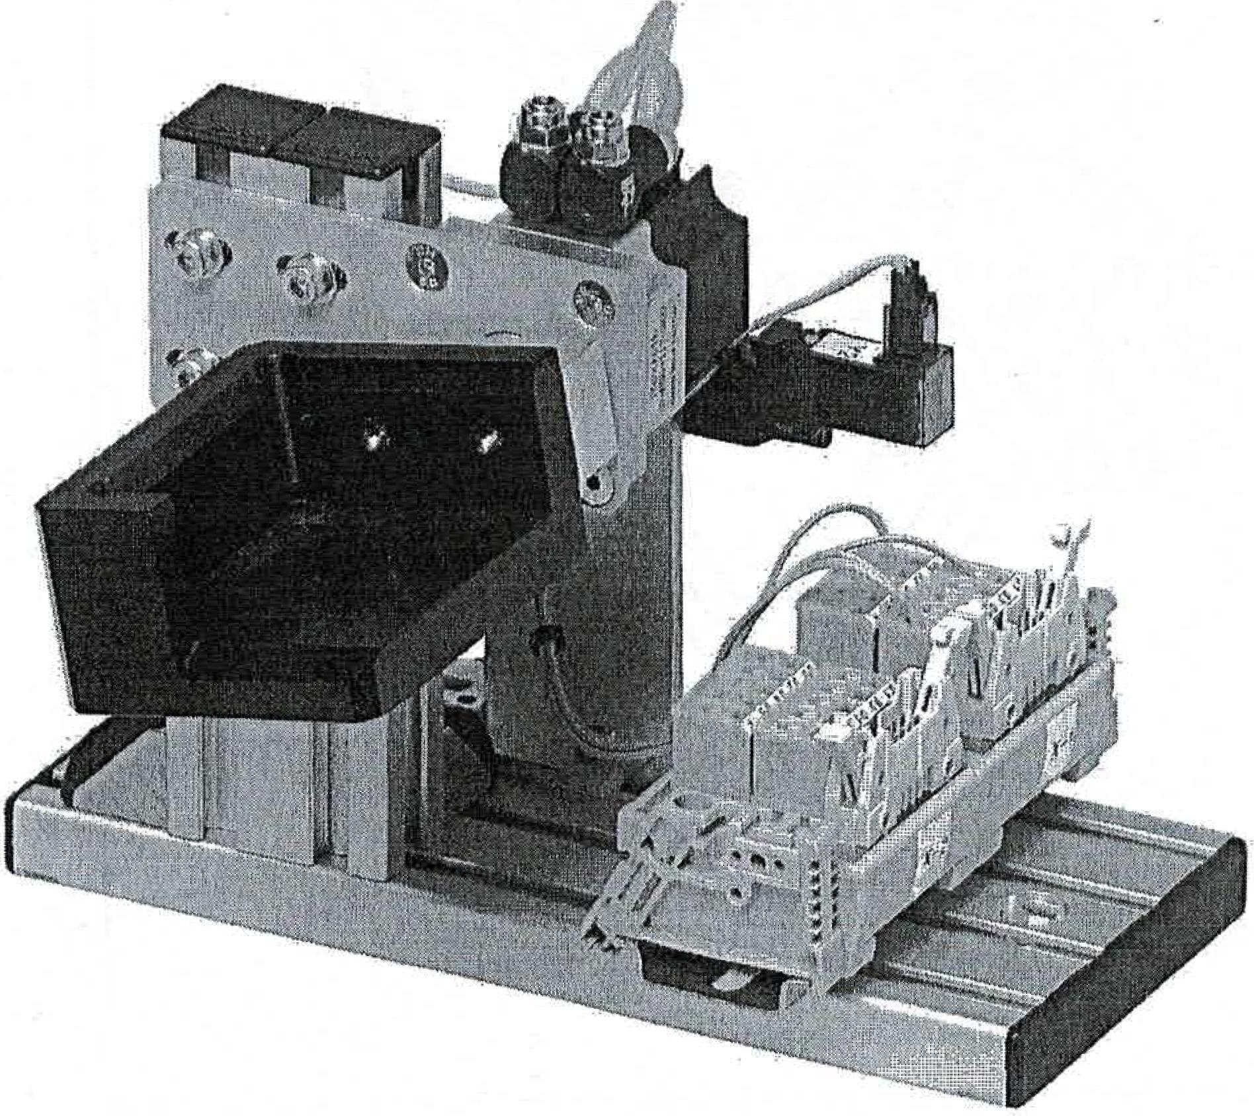

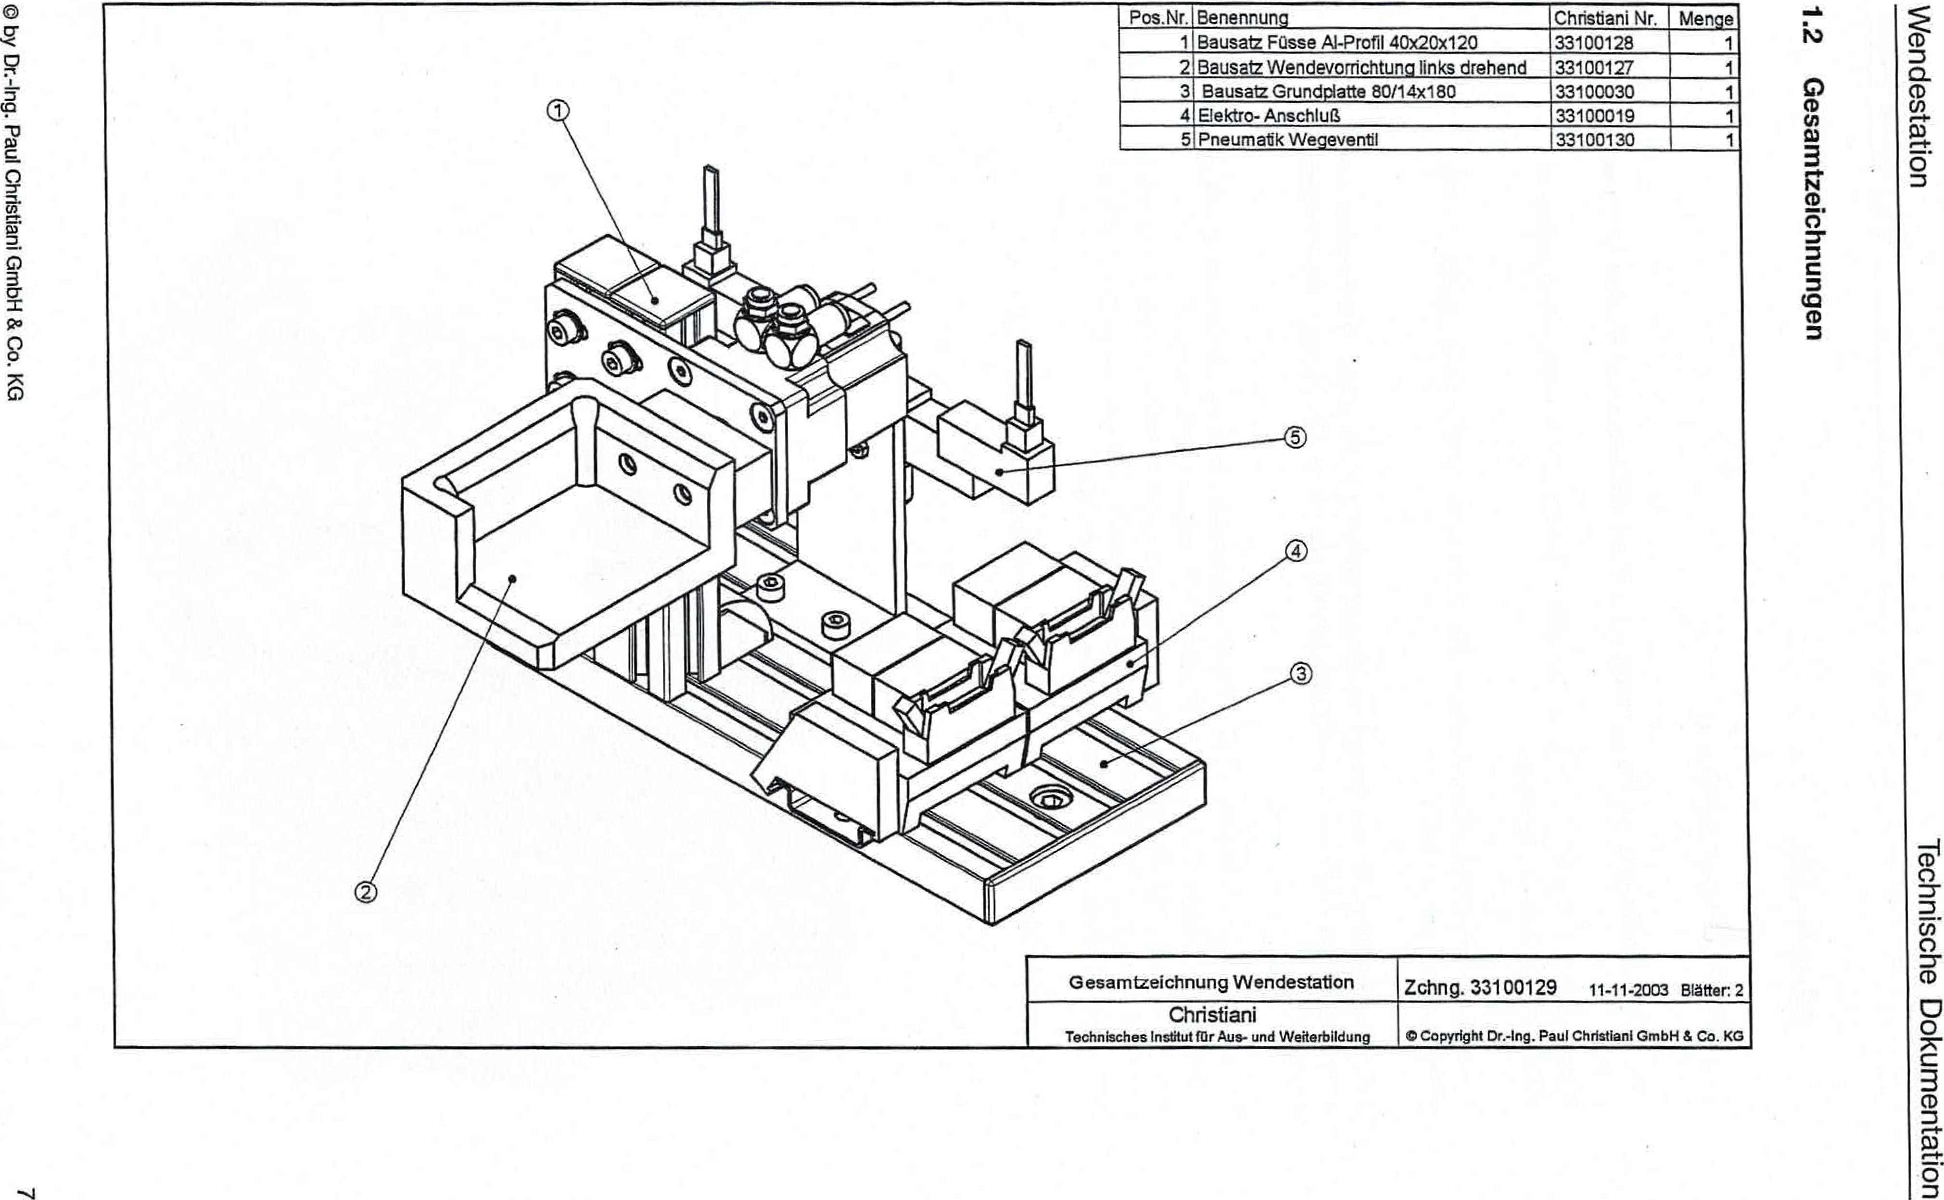

© by Dr.-Ing. Paul Christiani GmbH & Co. KG

■.4

**uaßuntmanwesa9**

uoRulsepuem

uopluawnloG agospLpai

General information turning station

Drawing 33100129 11-11-2003 Pages: 2

Christiani

Technical Institute for Education and Training

tgt Copyright Dr.-Ing. Paul Christian' GmbH & Co. KG

|  |  |  |  |
| --- | --- | --- | --- |
| Item No. | designation | Christiani No. | Crowd  1 |
| 1 I | Kit feet Al profile 40x20x120 | 33100128 |
| 2 | Kit turning device left-turning | 33100127 |  |
| 3 | Base plate kit 80/14x180 | 33100030 | 1 |
| 4 | Electrical connection | 33100019 | 1 |
| 5 | Pneumatic directional valve | 33100130 | 1 |